# prepare milstone& survey list

# MODULE IN

**PRINCIPLES IN CROP PROTECTION (CP 1)**

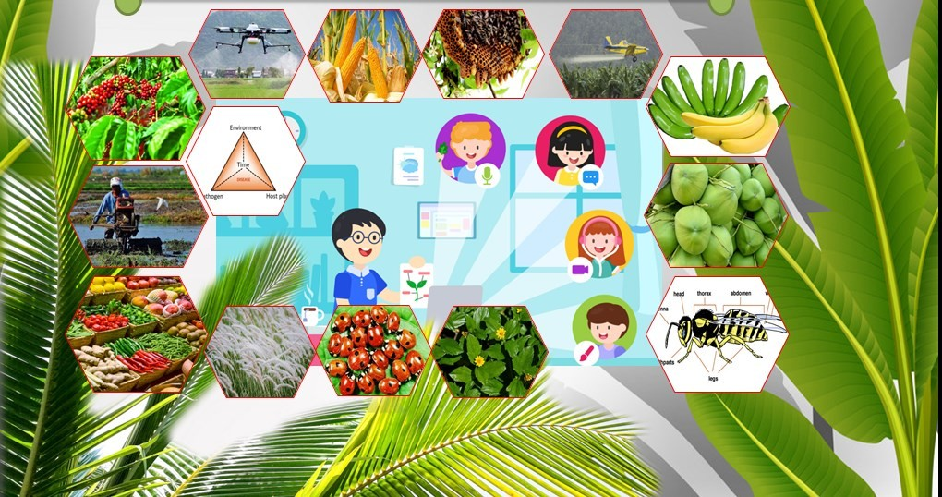

**PREFACE**

Like humans, pests eat in order to live. The study of Crop protection is essential for humans to comprehend, research, apply, extend and produce and to able to contribute solutions to problems in crop production and provide additional knowledge in agriculture.

Crop Protection is stimulating, attention-grabbing, vital, and worth studying because as a science it has a hands-on and upright goal of protecting the food available for humans and animals. The existence of plant pathogens, arthropods, weeds and vertebrate pests inhibit the crop growing in some areas or of food crops growth but other plants may attack, tear parts or entire field and reduce much of the expected produce before harvest or consumption.

Diseases, arthropods, weeds and vertebrate pests together predictably estimated annual interfere with the production, or destroy, between 31 to 42% of all crops produced worldwide. The losses are usually higher in the developing countries and lower in more developed countries.

The management and control measures to plant pest and diseases limits the total land available for farming each year. It can limit as well the kinds of crops that can be grown in fields already contaminated with certain microorganisms *e.i Fusarium* Tropical Race 4. Every year millions of tons of pesticides for treating seeds, fumigating soils, spraying plants and treatments needed for postharvest fruits and vegetables.

It is therefore the responsibility and goal of crop protectionists to balance all the factors involved so that the maximum amount of food can be produced with minimal side effects to the people and to the environment.

#### COURSE OUTLINE

SDSSU VMGO

Course Requirements Grading System

#### INTRODUCTION

* 1. World population and food supply.
  2. Role of Crop protection in increasing food supply
  3. Definition of Pest (s)
  4. Economic importance of pests.

#### PRELIMINARY

* 1. **Principles of Entomology**
     1. Definition of Entomology.
     2. History of Entomology
     3. Distinguishing Characteristics of Insects.
     4. General Structures of Insects.
     5. Tagmosis and Body Wall
        1. Insect Integuments/Exoskeleton
        2. Head
        3. Mouthparts
        4. Antennae
        5. Eyes
     6. Locomotory appendages
        1. Legs
        2. Wings
        3. Abdomen
     7. Metamorphosis of Insects
        1. Types of Metamorphosis
        2. Stages of Metamorphosis
        3. Types of Pupa
        4. Reproduction in Insects
     8. Classification and Indentification of Insects
        1. Classification
        2. Nomenclature
        3. Identification
        4. Taxonomy
     9. Common Insect Pests of Major Crops in the Philippines
        1. Insect Pests of Coconut
        2. Insect Pests of Vegetables
        3. Insect Pest of Corn
        4. Insect Pest of Durian
        5. Insect Pests of Stored Products
        6. Insect Pests of Cereals
     10. Concepts of Pests 10.1.Classification of Pests
     11. Classification based on origin
     12. Classification based on abundance or number
     13. Classification of Insect Pests in Storage
         1. According to number
         2. According to capacity to infest Sound Kernel
         3. Kinds of Insect Damage 10.1.3.3.1. Direct damage 10.1.3.3.2. Indirect damage
     14. Classification of insect based on feeding habit
         1. Phytophagous insects
         2. Saprophagous
         3. Mycetophagous
         4. Zoophagous
     15. Pesticides Calculation and Calibration of Application Equipment
         1. Calibration of Application Equipment
         2. Pesticide Calculations

#### MIDTERM EXAMINATION

1. Weeds Science
2. Concepts of a Weeds
3. Characteristics of a weed
4. Advantages/Benefits from weeds
5. Disadvantages/Harmful Effects
6. Classification of Weeds
   1. Based on outward appearance or gross morphology
      1. Grasses
      2. Sedges
      3. Broadleaves
   2. Based on Maturity Period or Life Cycle
      1. Annual Weed
      2. Perennial weed
   3. Based on Manner of Reproduction
      1. Sexual weed
      2. Asexual weed
         1. Rhizome
         2. Stolon
         3. Tuber
         4. Off-shoot
   4. Based on habit of stem growth
   5. Based on habit or place for preferred growth
   6. Based on the Inflorescence or Floral Structure of the Plant
7. Establishment of Weeds
   1. Viability of Weed Seeds
   2. Dormancy

7.2.1 Mechanisms of Dormancy

7.2.2. Ways of Breaking Dormancy

1. Seed Germination
   1. Steps Involved in Seed Germination
      1. Imbibition
      2. Period of Rapid Metabolic Activity
      3. Emergence of root
      4. Emergence of Shoot
      5. Period of idependent growth
2. Factors Acceting Weed Germination
   1. Environment
   2. Cultural Factors
3. Seedling Growth and Development
   1. Seedling Form Vs. Mature Form
   2. Factors Affecting Seedling Growth and Development
      1. Soil Factors
      2. Ligth
      3. Adaptation to Growing Condition
      4. Competitive Power of the Weed
4. Crop-weed Competition
5. Major Factors for Competition
   1. Competition for nutrients
   2. Competition for Water
   3. Competition for light
6. Physiological Basis for Plant Comptetition
7. Allelophaty
8. Classification of Allelopathic Substance
   1. Antibiotic
   2. Marasmin
   3. Phytoncide
   4. Koline
9. Methods and Techniques in Weed Management
   1. Prevented Methods
   2. Physical/Cultural Methods
   3. Biological Control
   4. Chemical Control
10. Pointers in the Proper Use of Herbicides

#### PREFINAL EXAMINATION

1. Plant Pathology
   1. Etymology of Pathology
   2. Definition of Phytopathology
   3. The Science and Art of Plant Pathology
   4. The Raison d’etre and Ultimate Objective of Plant Pathology
   5. The Economic Importance of Plant Diseases
   6. Examples of Losses in the Philippines
   7. Types of Crop Losses
2. Historical Development of Plant Pathology
   1. Pre-scientific Period
   2. Beginnings and Advances in Scientific
   3. Development of Plant Pathology in the Philippines
3. Concepts of Plant Disease
   1. Definition of Disease
   2. Disease Vs. Injury
   3. Salient Points in most of the Definitions of Disease

#### FINAL EXAMINATION

1. Definitions and Terminology in Plant Pathology
2. Requisites for Disease : Disease Triangle
3. Symptoms of Plant Disease
   1. Primary vs. Secondary symptoms
   2. Localized Vs. Systemic symptoms
   3. Histological vs. Morphological Symptoms
   4. Plesionecrotic symptoms vs. Necrotic symptoms
   5. General Classification of Symptoms
      1. Hypoplastic Symptoms
      2. Hyperplastic Symptoms
   6. Specific Symptoms and Their Description
4. Signs
   1. Categories of Signs
      1. Reproductive structure
      2. Disease Products
      3. Reproductive Structure
   2. Vegetative Structures
   3. Reproductive Structures
   4. Disease Products
5. Plant Disease Diagnosis
   1. Plant Problem Diagnosis: Preliminary Considerations
   2. Plant Problem Diagnosis Steps
      1. Consider the Possible Agents
      2. Consult Literature Resources for Possible Diseases and Disorders.
      3. Investigate Symptom Progression
      4. Ask questions
      5. Observe Patterns
      6. Review of Cultural Practices
      7. Review of Environmental Conditions
      8. Check Host Specificity
      9. Check for Symptoms and Signs
      10. Identify and Classify Symptoms
      11. Identify Plant Parts Affected
      12. Laboratory Examination and Testing
      13. Investigate Pathogenicity
          1. Koch’s Rules of Proof of Pathogenicity
      14. Final Diagnosis
      15. Develop Control Recommendation and Present to Grower

14. Vertebrate and Invertebrate Pests of Crops

1. **REFERENCES**

**VISION**

A leading “Global” University with widened academic perspectives that focus on attaining food security, supporting poverty alleviation, developing renewable energy, and conserving natural environment.

### MISSION

SDSSU shall provide competency-based higher education training driven by relevant and responsive instruction, research, extension and sustainable resource management.

Particularly, SDSSU is committed to:

1. Produce competent and skilled graduates prepared for gainful employment;
2. Develop graduates who shall not only foster economic progress but also care for the environment, adhere to positive value system, and preserve cultural heritage;
3. Engage in high-impact research for instruction and develop technology for food security and renewable energy;
4. Collaborate with government and non-government agencies to help improve the lives of the marginalized groups; and
5. Promote cooperation/partnership among regional, national, and ASEAN institutions in Higher Education.

### Program Goals:

* 1. Provide quality and relevant education and training within the reach of low-income members of the society.
  2. To provide students with entrepreneurial skills and trainings in the field of agri- business, commercial sciences, Information technology and allied courses.
  3. To produce graduates equipped with the necessary values, attitudes, knowledge and skills.

***Specific Program Outcomes :***

*The graduates shall be able to:*

1. Exhibit comprehensive knowledge of various learning areas in Bachelor of Agricultural Technology curriculum
2. Execute techniques, skills and utilize modern tools necessary for agricultural activities
3. Create and implement assessment tools and procedures to measure learning outcomes for technical expertise and production.

### Course Requirements:

1. Weed herbarium
2. Collecttion and preservation of Arthropods
3. Collection of Pesticide labels
4. Permanent mounts of crop diseases
5. Educational Tour/Field Trips to Regional Crop Protection Center(Optional)
6. Interview to Farmers and Technicians on Pest Management.

➲ **What this Module is about?**

This 3-unit course is intended for first year agriculture students. It introduces to students the principles in crop protection including in the field of entomology, weed science, plant pathology and vertebrates and invertebrates of crop pests, including the history, identification and classification, biology and ecology of different pests and their natural enemies. To this end, the course provides an overview of the various fields in crop protection comprising the signs and symptoms of diseases, and diagnosis of plant diseases.

This is a self-instructional module for undergraduate students of Surigao del Sur State University-Tagbina Campus. This module comprises of 4 modules. Each module corresponds to term of examination (Prelim, Midterm, Prefinal and Finals) with different lessons and exercises prepared for agriculture students to be accomplished in this manual which are expected to be submitted to the faculty during scheduled face-to-face encounter by batch.

The exercises provided give emphasis in bridging the gap between theory and practice. Undergraduate students are expected to analyze the concepts presented and apply these at their own farm/home. The exquisiteness of self-instructional module is that the student learn at his/her own phase. Before answering the exercises, the student should have fully understood the concepts presented. No one could stop him/her to read the manual many times.

➲ **Introduction**

For an appreciation of this module, it is desired that readers should have a clear understanding of principles in crop protection. Handling of crop protection products, proper identification of pests and diseases and related farm activies are few of the goals in this subject. Hence, to provide a clear view of crop protection, we have to conceptualize it as an educational endeavor geared towards helping the agriculture students to help also local farmers, i.e. make them more confident and self-reliant by acquiring new knowledge, skills, new attitude, new understanding, appreciation and perception to enable them to hastily think through and arrive at solutions to pest and diseases problems in the field.

Teaching crop protection is a difficult and at the same time a challenging job. Moreover, working with local farmers in the rural areas can be exasperating and challenging. However, this should not diminish the interest nor the desire of the agriculture students/field technician to put across his ideas to the clientele in clear and meaningful ways to achieve the desired goals of bringing appropriate, effective and environment friendly solutions to the problem in which they are deeply immersed.

Hence, it envisions to convey students and eventually to farmers through this teaching module more meaningful principles, approaches and strategies to help uplift the living condition of farmers in the rural areas and country as a whole. It will attempt to simplify concepts, philosophy, activities and procedure connected to crop protection. The lessons of this module includes (i) Principles in entomology; Weeds Science (ii); Plant pathology (iii); Historical development in crop protection (iv); role of crop protection in crop production (v); plant pests and diseases diagnosis (vi); and vertebrates and invertebrates pest of crops.

**Lesson 1: World Population and Food Supply**

✪ **Objectives**

At the end of this lesson, you are expected to:

1. Compare the population of various countries and distinguish its impact to food supply;
2. Identify the role of crop protection in crop production;
3. Identify the various features and benefits of arthropods to agriculture and define terms related to the topics.

**🕜 Suggested Timeframe: 5 hours**

In this particular lesson lesson, you are expected to finish reading, evaluating the 3As (Activity, assessment and assignment) and summarizing the lesson.



**Discussion**

### World Population

Understanding global demographic trends is essential for government, business planners, and in agriculture offering insights into resolving numerous challenges. World population growth is slightly ahead of what was projected a few years ago. More than half of the world lives in urban areas today, and that is expected to rise to 70 percent by 2050 (USBC, 2016). Most population growth will continue in less developing nations while advanced economies experience population declines and greater proportions of elderly citizens due to increased life expectancy and reduced fertility rate. More than 80 countries, half the world’s population, now post fertility rates below the replacement level. That leaves fewer workers available to support each individual over age 65, compelling governments and individuals to prepare for long retirements. Good planning can also prevent a variety of other hardships including food and water shortages, poverty, environmental degradation and even security crises.

The world population is about 7,439,384, 216 and Philippines got the 12th spot as most populated countries in the world (USBC, 2016) as shown in figure 1. In relation to this, the more people the countries have the more human resource it has but one of the consequences is food shortage.

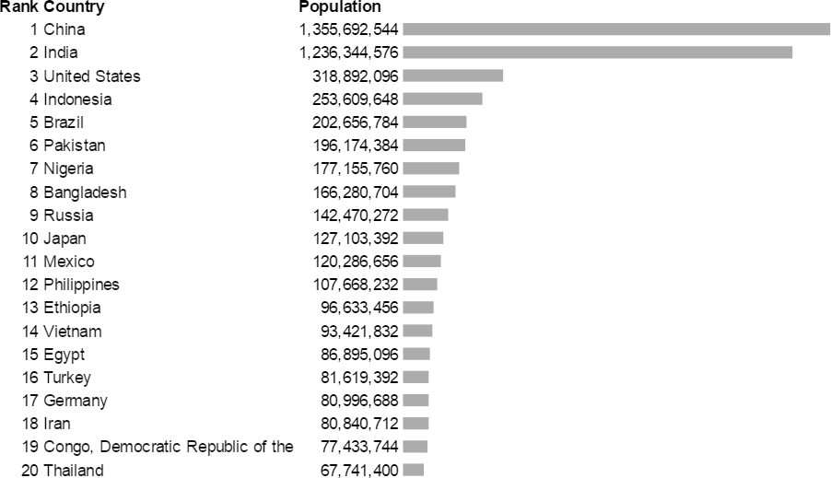

Figure 1. The world population

**Source:** *US Bureau of the Census, 2016*